MILESTONE 1

LOGIN AND REGISTRATION

Tim A James

GCU | CST-236 DATABASE APPLICATIONS II | 2/28/21

# GITHUB REPO URLS

MILESTONE 1 REPO: <https://github.com/tjames222/CST-236/tree/main/WEEK%201/MILESTONE%201>

ECOMMERCE SITE REPO: <https://github.com/tjames222/CST-236/tree/main/EcommerceSite>

# WIREFRAMES

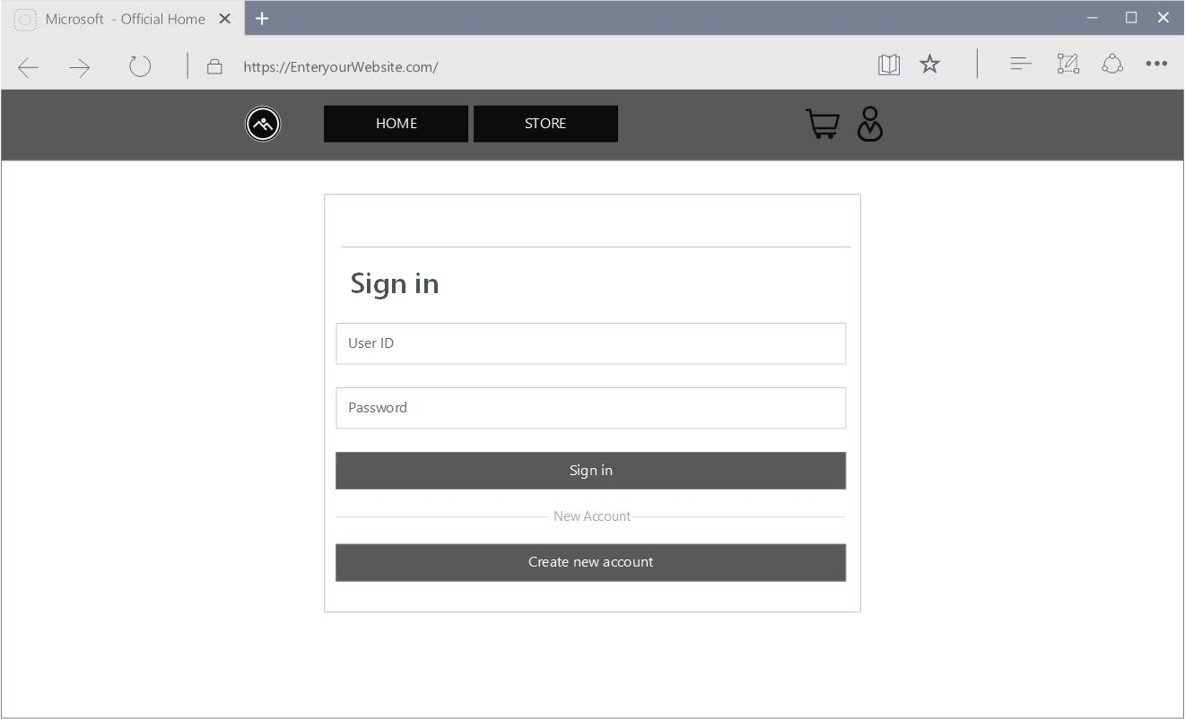Login Page.

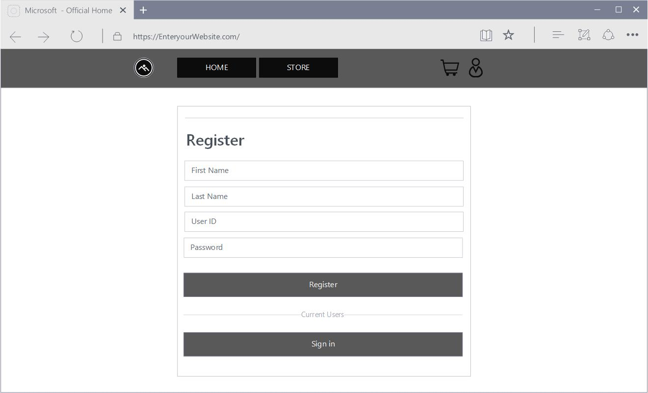Register page.

# ER DIAGRAM

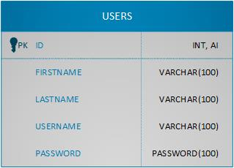Users ER diagram

# UML DIAGRAM

User Class UML Diagram.

# 

# SCREENCAST URL

<https://www.loom.com/share/dfb945525ac1459ca0bab6a3de75b59a>